**Favcy - Builder X | Idea To Grants**

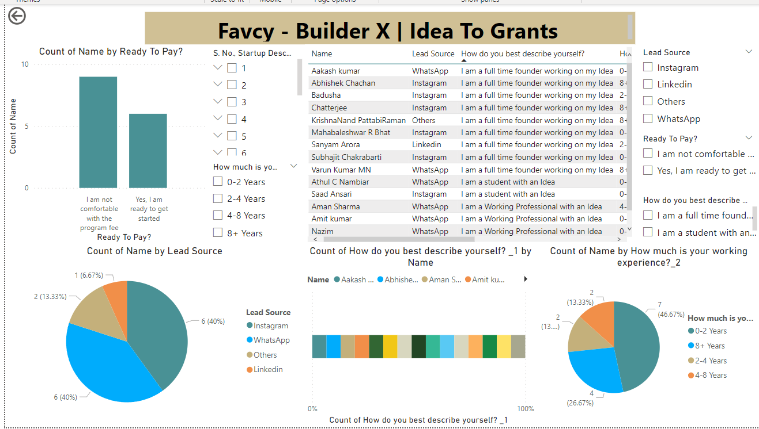

This ***Power BI report provides*** a comprehensive overview of the startup leads collected from various sources and their readiness to participate in the program.

***Visualizations:***

**1. Count of Name by Ready To Pay?**

- Description: This bar chart displays the number of founders based on their readiness to pay the program fee. 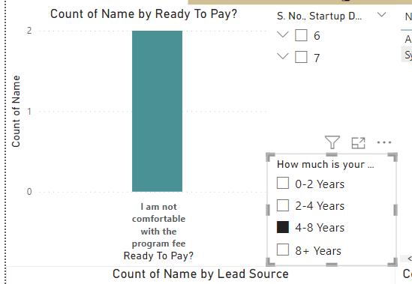

- Insight:

- A higher number of founders (10) are not comfortable with the program fee compared to those ready to get started (6).

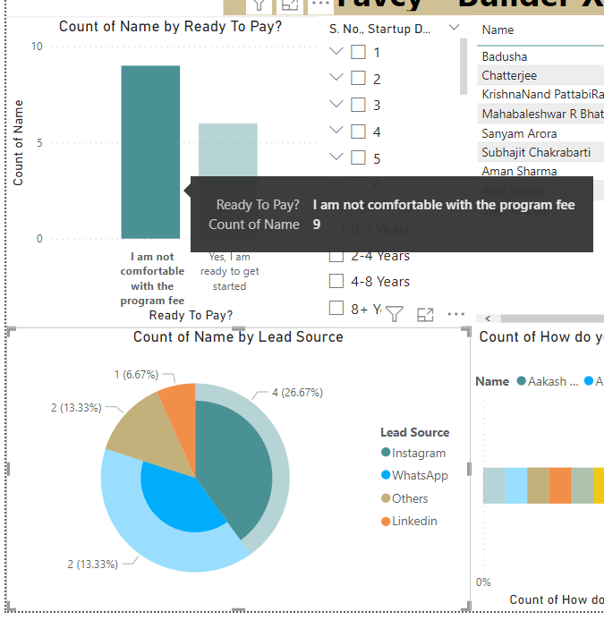

**2. Count of Names by Lead Source**

- Description: This pie chart illustrates the distribution of leads based on their sources.

- Insight:

- WhatsApp and Instagram are the leading sources, each contributing 40% of the total leads.

- Other sources include LinkedIn (13.33%) and others (6.67%).

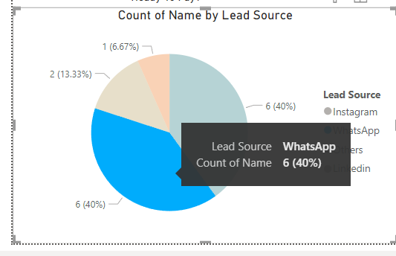 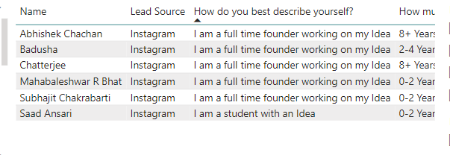

**3. Detailed Table of Startup Leads**

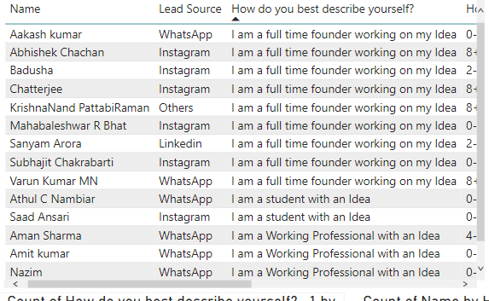 - Description: This table provides detailed information on each startup lead, including the founder’s name, lead source, self-description, working experience, and their comfort level with the program fee.

- Columns Included:

- Name

- Lead Source

- How do you best describe yourself?

- How much is your working experience?

- Ready To Pay?

- Startup Description

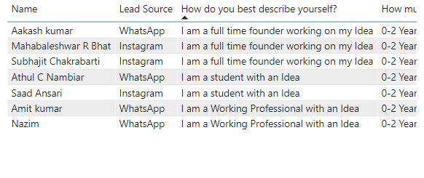

**4. Count of How do you best describe yourself? by Name**

- Description: This bar chart shows the self-description of founders.

- Insight:

- A majority describe themselves as full-time founders (9).

- Others include working professionals (4) and students (3).

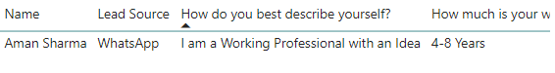

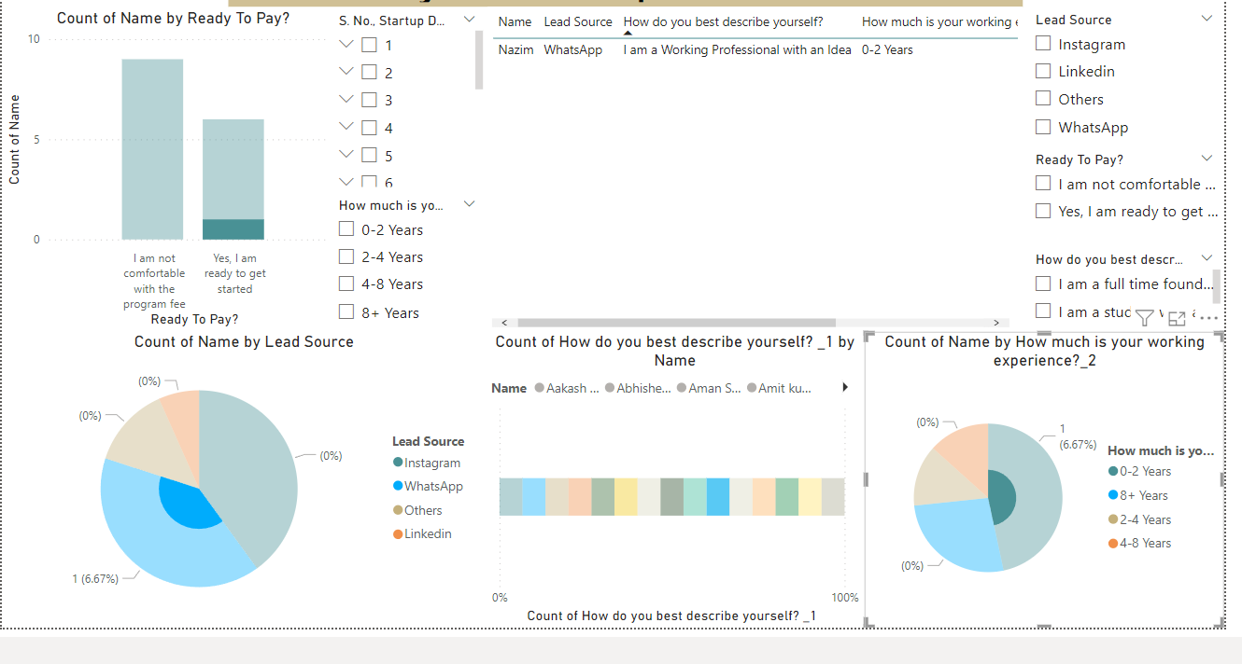

**5. Count of Name by How much is your working experience?**

- Description: This pie chart visualizes the distribution of founders based on their working experience.

- Insight:

- Most founders have 0-2 years of experience (46.67%).

- Other groups include 4-8 years (26.67%), 2-4 years (13.33%), and 8+ years (13.33%).

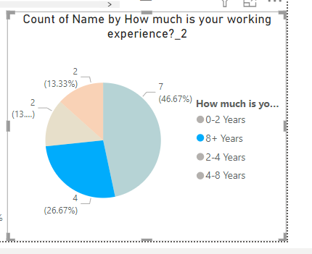

***Filters:***

1. Lead Source

- Description: This slicer allows you to filter the data based on the source of the lead (Instagram, LinkedIn, Others, WhatsApp).

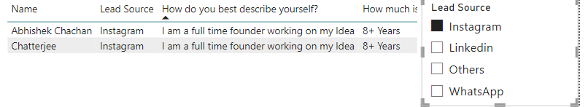

2. Ready To Pay?

- Description: This slicer lets you filter the data based on the founder’s readiness to pay the program fee.

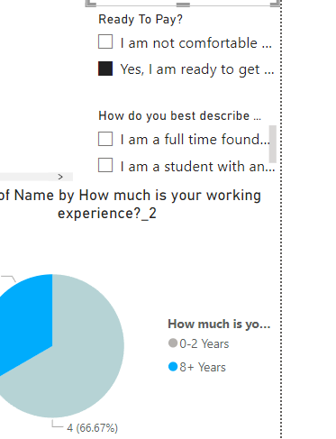

3. How do you best describe yourself?

- Description: This slicer helps you filter the data based on the founder’s self-description.

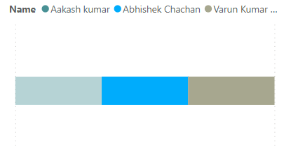 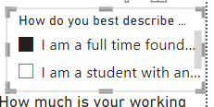

4. How much is your working experience?

- Description: This slicer enables filtering based on the founder’s working experience.

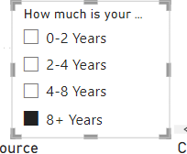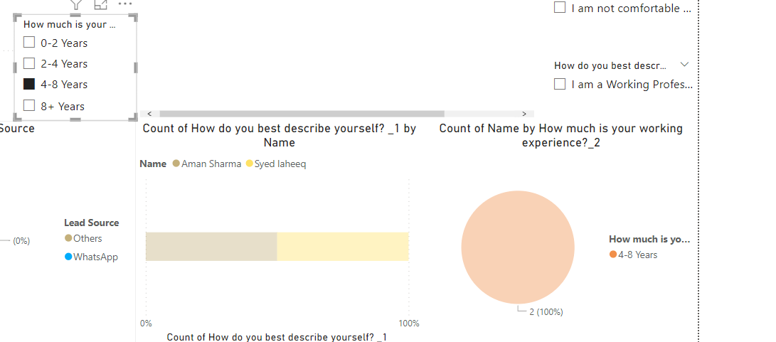

***Key Insights:***

- Lead Source Distribution: WhatsApp and Instagram are the most effective channels for reaching potential founders.

- Founder Profile: Most founders are full-time founders with varying levels of working experience.

- Payment Readiness: A significant portion of founders are hesitant about the program fee.

This report provides a clear and detailed view of the startup ecosystem, helping stakeholders understand the profile and preferences of the founders. It also highlights the effectiveness of different lead sources, which can guide future marketing and outreach efforts.